**EXPERIMENT 2:**

DATE: 01.03.24

2.Write the python program to solve 8-Queen problem

**AIM:**

The aim is to solve the 8queen problem using python program.

**PROGRAM:**

import random

def game():

number = random.randint(1, 100)

num_guesses = 10

while num_guesses > 0:

guess = int(input(f'Guess a number between 1 and 100 (you have {num_guesses} guesses left): '))

if guess == number:

print('Congratulations, you guessed the number!')

return

if guess < number:

print('Too low, try again.')

else:

print('Too high, try again.')

num_guesses -= 1

print(f'Game over, the number was {number}.')

game()

**INPUT:**

Guess the number:

Too low, try again

Guess the number:

Too high, try again

Guess the number:

Congratulations you guessed the number

**OUTPUT:**

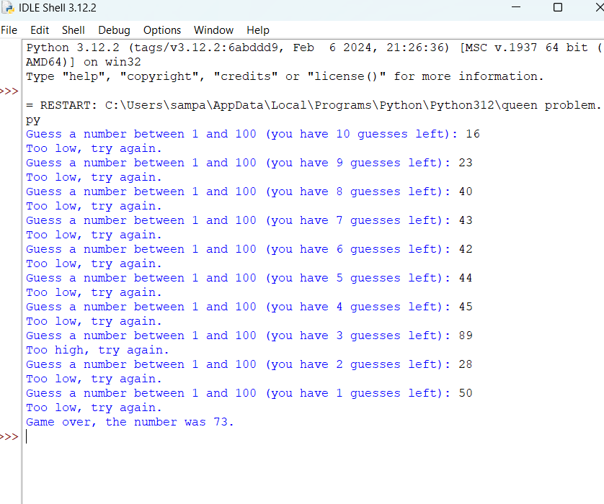

**RESULT:**

The 8queen problem using python program executed successfully.